PC 633 Michael J Amos BSc. (Hons)
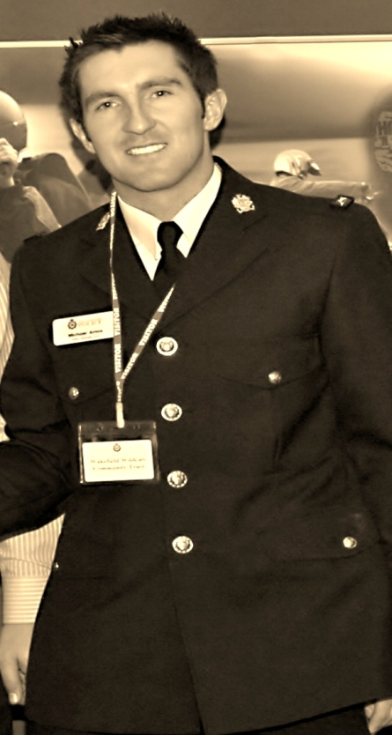

Wakefield Police
Schools Liaison Officer

Portfolio of Work & Acknowledgements
November 2006 – December 2011

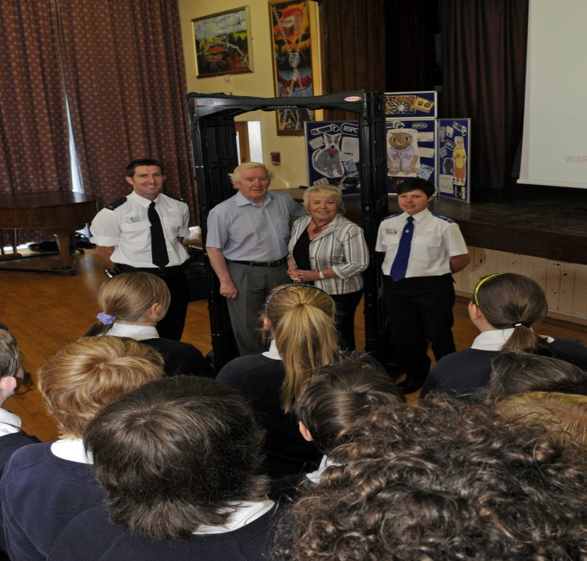 |  |  |  |  |  |  |  |  |  |  |  |  |  |  |  |  | 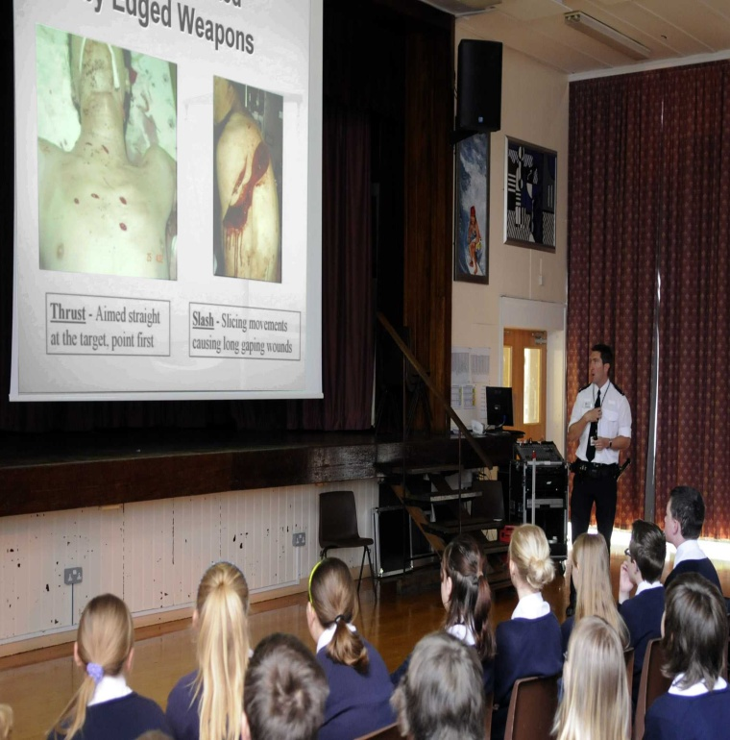
SAFETY ARCH PRESENTATIONS

PC Amos organised 15 Safety Arch Presentations showing pupils that the West Yorkshire Police are committed to keeping their community safe. This reached 3500 pupils aged 11-16. Invited to attend the sessions were Councillor Graham and Councillor Hopkins to inform constituents of the education the children received.

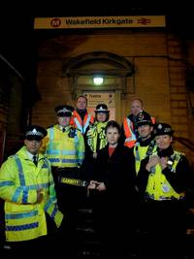

SAFETY ARCH ENFORCEMENT

PC Amos volunteered to work alongside BTP to show MP Mary Creagh the benefits of the safety arch
on public safety at Kirkgate Train Station, Wakefield.

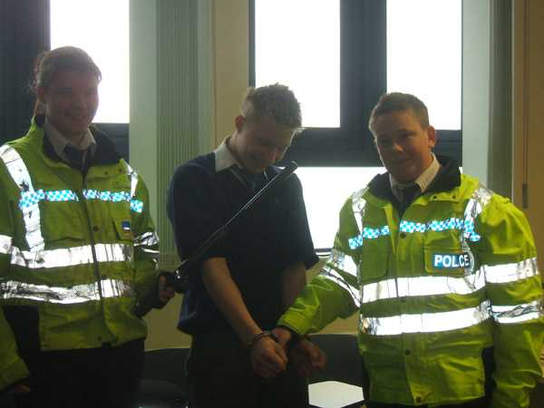  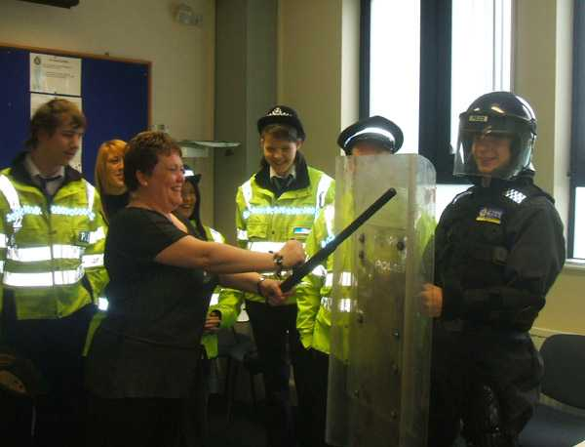  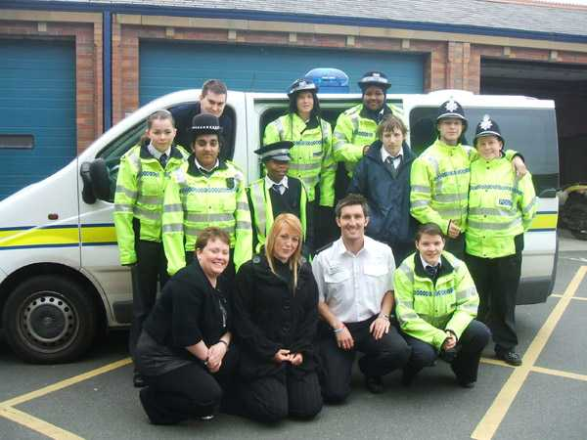  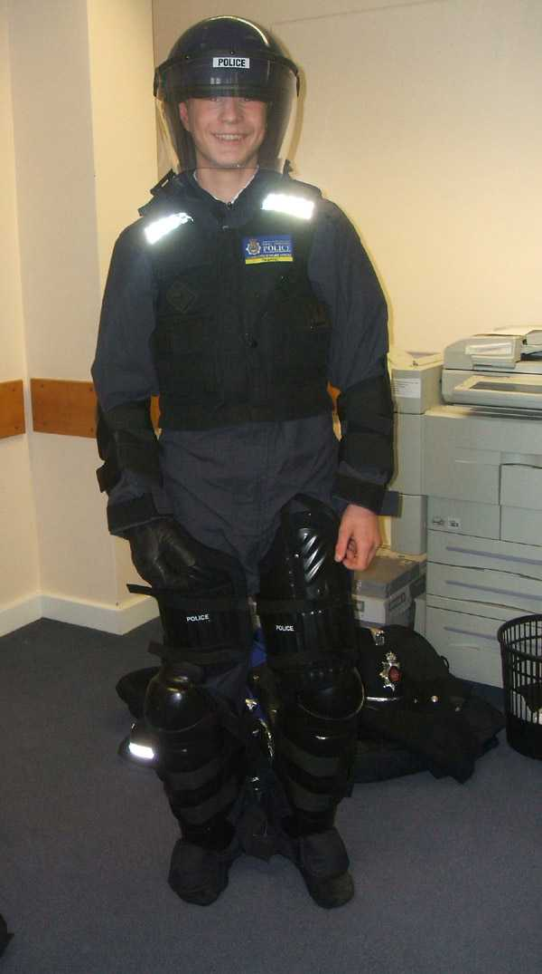 |  |  |  |  |  |  |  |  |  |  |  |  |  |  |  |  |  | 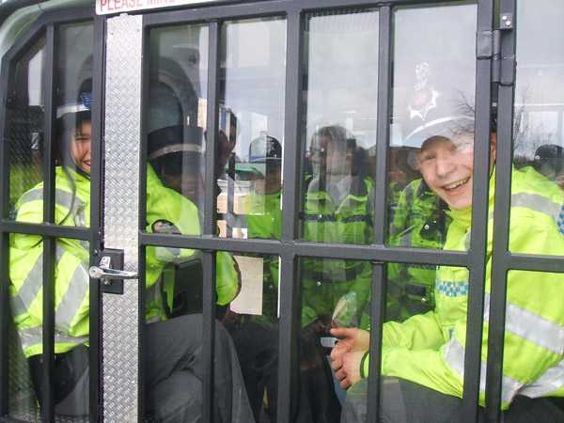  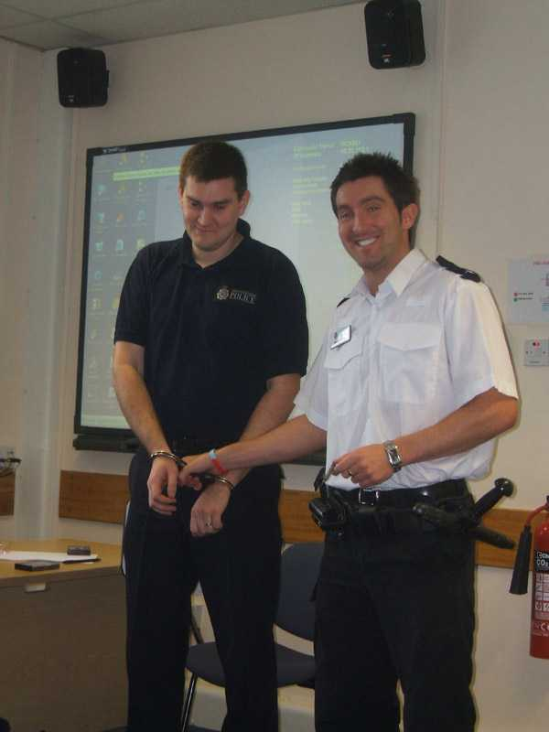
ASDAN – KETTLETHORPE

PC Amos organised station visits for 3 consecutive years for ASDAN pupils from Kettlethorpe School. ASDAN pupils can display challenging behaviour and have certain social problems. Their aim is to learn key life skills and the day aimed to break down barriers and understand choices and consequences around crime and ASB for themselves and society.

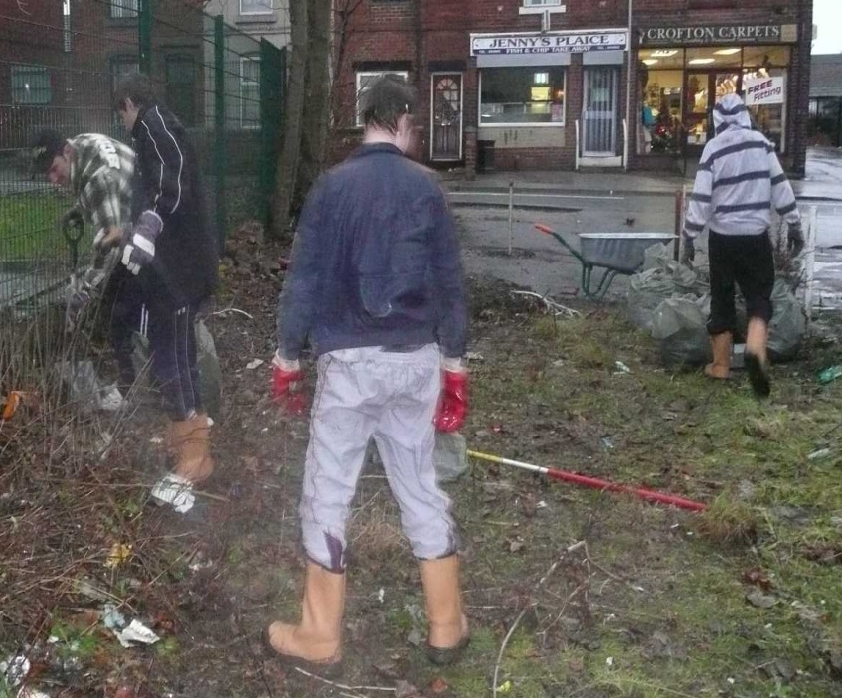

QUEST PROJECT

PC Amos organised a community clear up project as part of the West Yorkshire Police QUEST competition. Utilising hard to reach pupils they where engaged and educated in the effects of a clean environment on their community. The area we cleared was an Anti Social Behaviour hotspot close to their School. Local residents complimented the pupils as they worked on it one afternoon a week for 6 weeks.
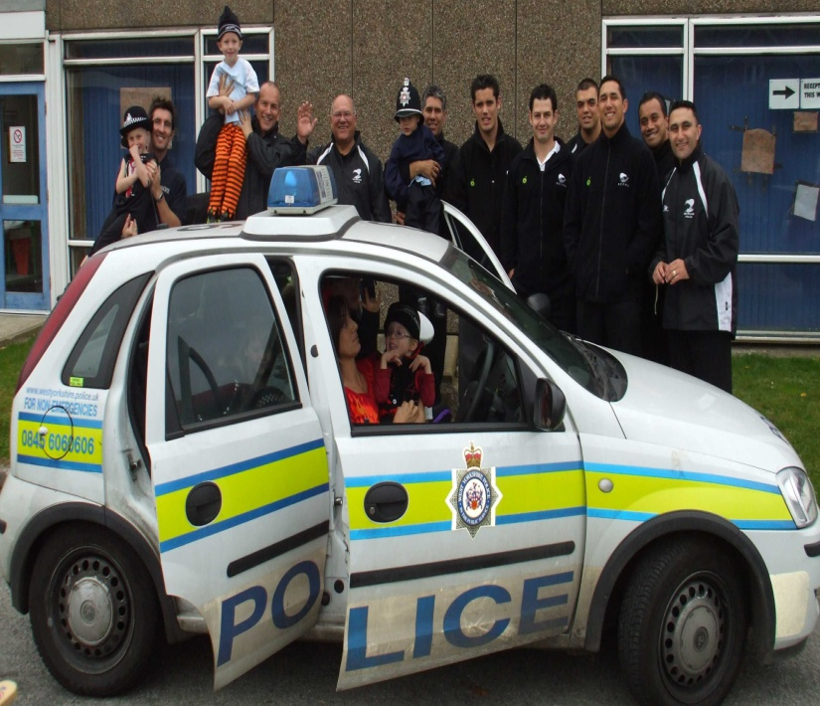
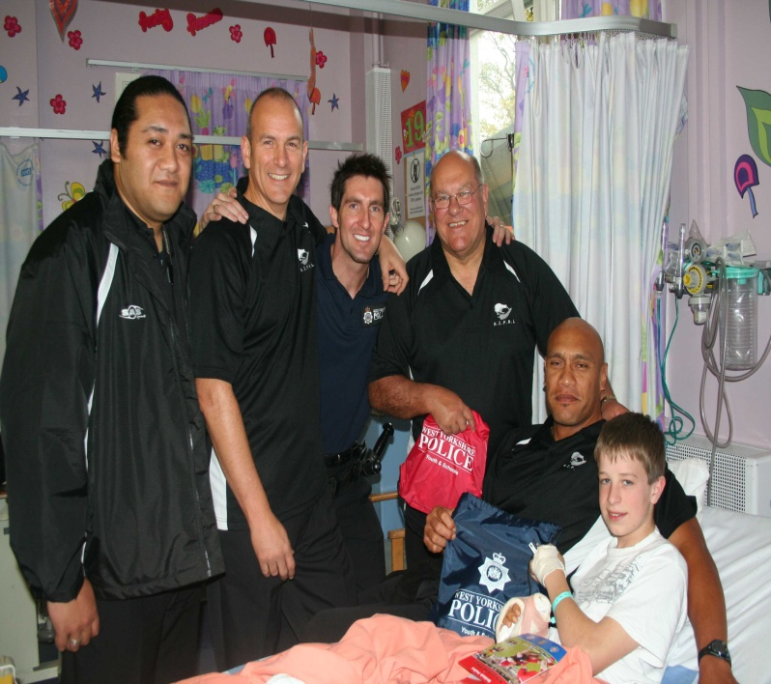

NEW ZEALAND POLICE VISIT

The New Zealand Police RL Team came to West Yorkshire and PC Amos organised for the KIWI Police colleagues to visit the local hospital and a primary School. The visitors engaged pupils whilst talking about their culture and conducted the HAKA amongst many other cultural traditions. We handed gifts to children in hospital and tried to put a smile on the young peoples faces.
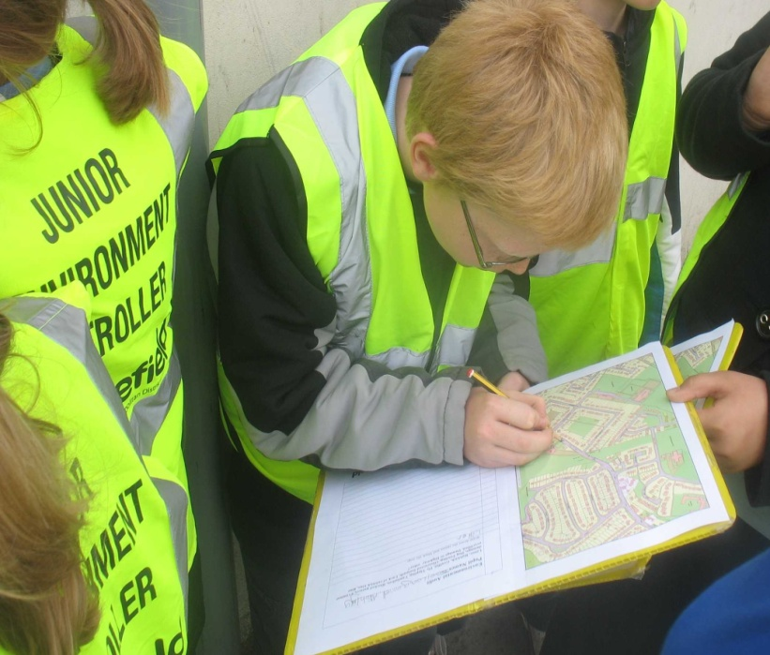
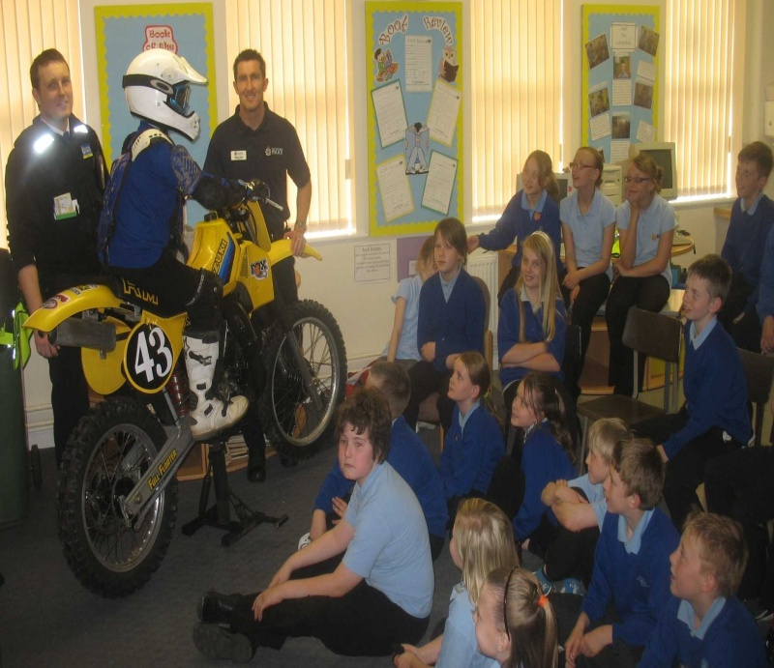
HAVERCORFT ENVIRONMENT VISUAL AUDIT (EVA)

PC AMOS worked in partnership with Year 6 children at Havercroft Junior and Infant School spent the day learning about their local environment. They had different presentations and activities and ended the day undertaking a environmental visual audit of the area around their School. This information is then passed onto the WMDC to clear up the areas the children highlight.

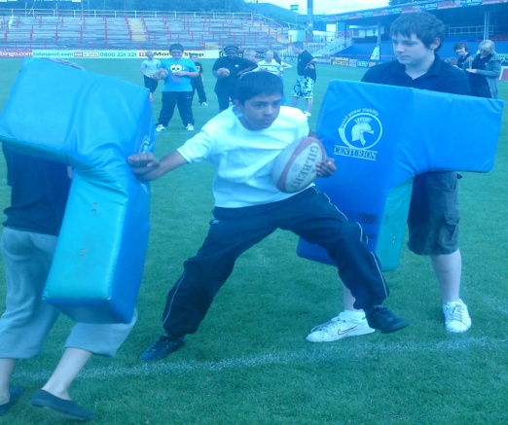

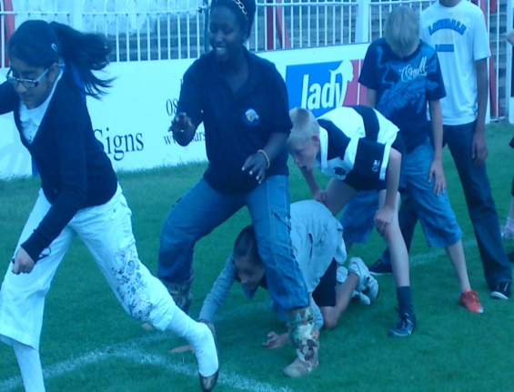

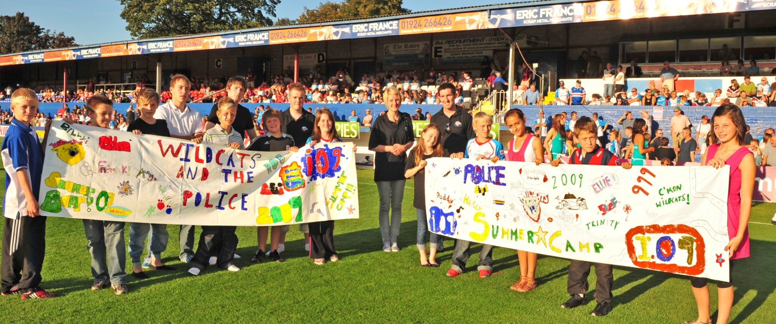

WEST YORKSHIRE POLICE I09 COMPETITION

PC Amos organised and was group leader of the I09 Community Summer Camp. Year 10 pupils (15yrs old) conducted a week of activities for local Year 6 pupils (10/11 years old) whilst in the School Holidays. The emphasis was on older children being role models to the younger children and giving the younger children positive activities to do. The week was a massive success and the whole group got to display their Police I09 Banners at a live Super League game.
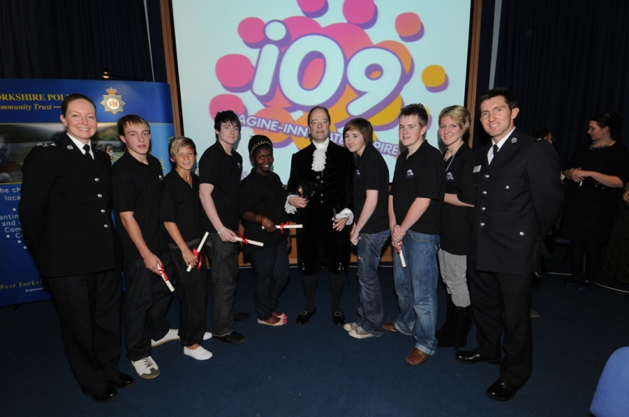

WEST YORKSHIRE POLICE I09 COMPETITION AWARDS EVENING

PC AMOS and the I09 Team came second out of over 40 entries in the West Yorkshire Police I09 Competition.
The High Sheriff of West Yorkshire handed out awards to the team.

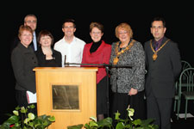

WAKEFIELD COLLEGE AWARDS EVENING

PC AMOS was contacted by Wakefield College to be the Guest of Honour at their awards evening. The request was orchestrated through the principal for ex pupils who have gone onto success after their college education. As well as handing out awards to pupils, PC AMOS was requested to do a speech on his life as a Police Officer and TV extra work.

http://www.wakefield.ac.uk/News/PressReleases/Articles/2008/12/LivingLifeGreatly.asp

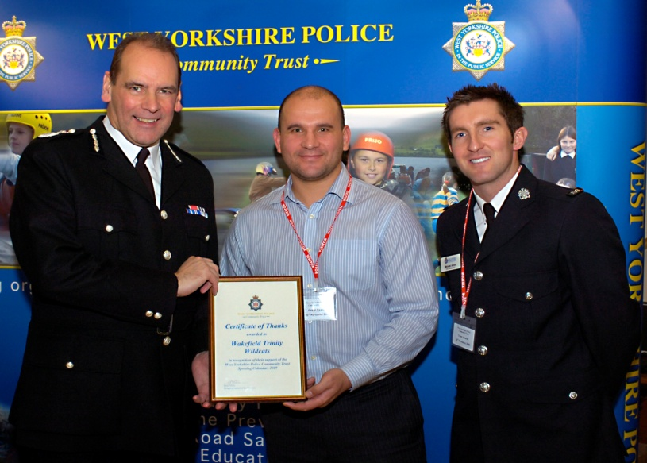

WEST YORKSHIRE POLICE COMMUNITY TRUST AWARDS EVENING

PC AMOS and Davide Longo accepting their Community Trust Award from Sir Norman Bettison.

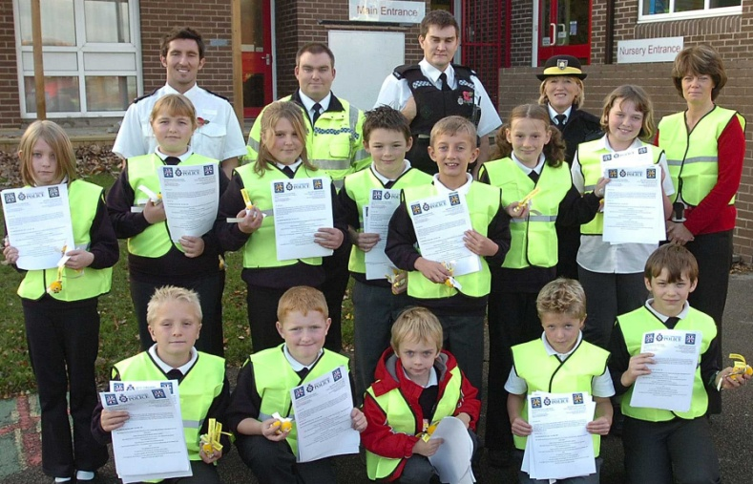 |  |  |  |  |  |  |  |  |  |  |  |  |  | 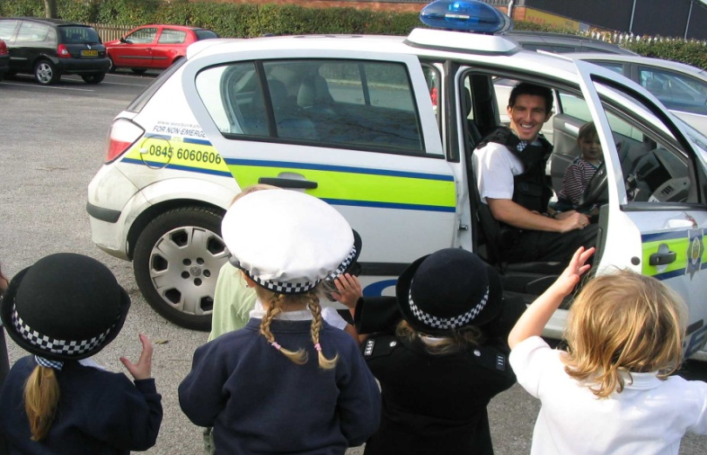
TOWNGATE PRIMARY SCHOOL PARKING SAFETY OPERATION

PC AMOS responded to Schools who highlighted a problem with pupil safety around School opening and closing time. Letters were devised which told parents to think of children’s safety when driving and parking in and around the School. The letter also contained the Highway Code and Green Cross Code for the pupils and parents to practice at home.

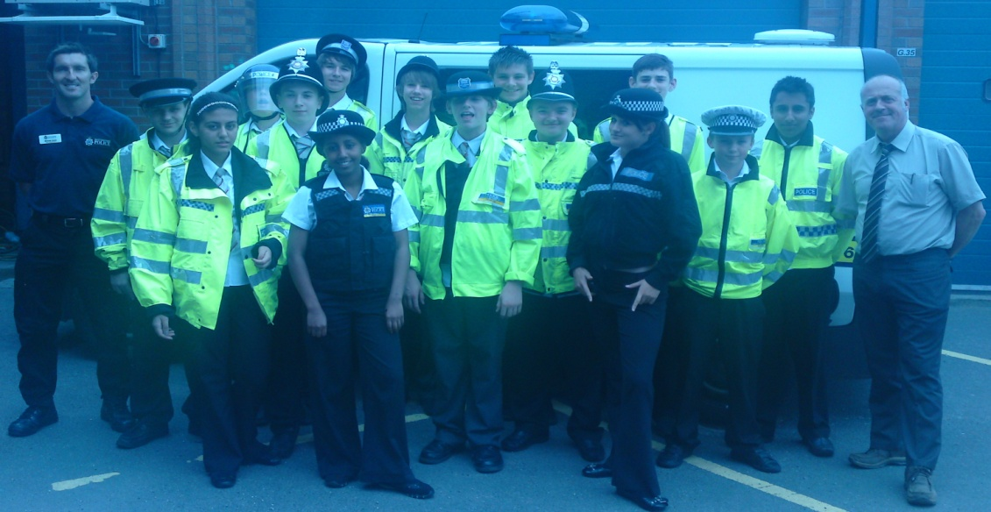

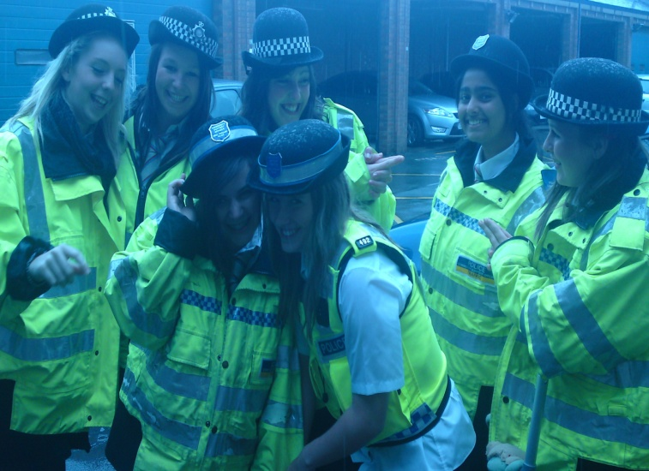

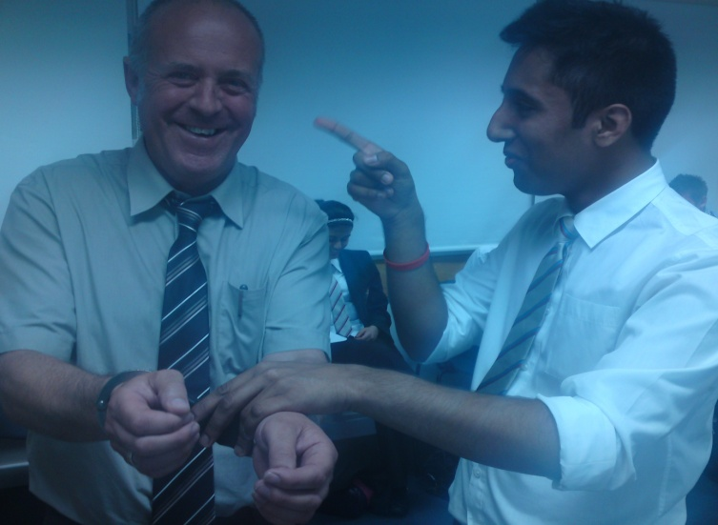

ST THOMAS A BECKETS YEAR 10 STATION VISIT

PC AMOS invited 3 groups of Year 10 Pupils from St Thomas a Becket School to Ossett Police Station to learn about Policing and responsibilities. The pupils got an insight into modern day policing and got into role as Police Officers for the day. They even got to arrest their own teacher and would only give him bail if homework was cancelled for a month!

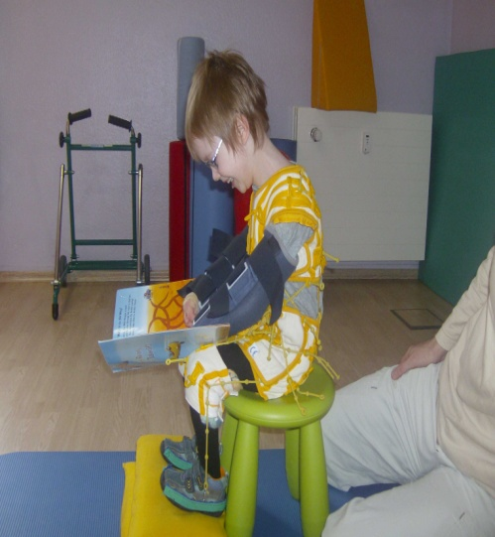  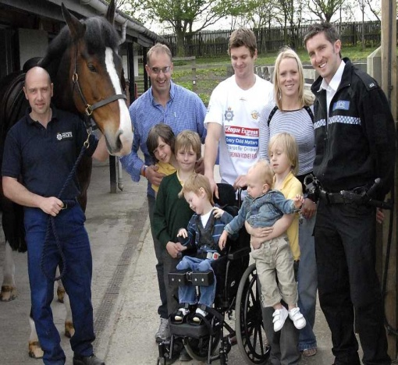  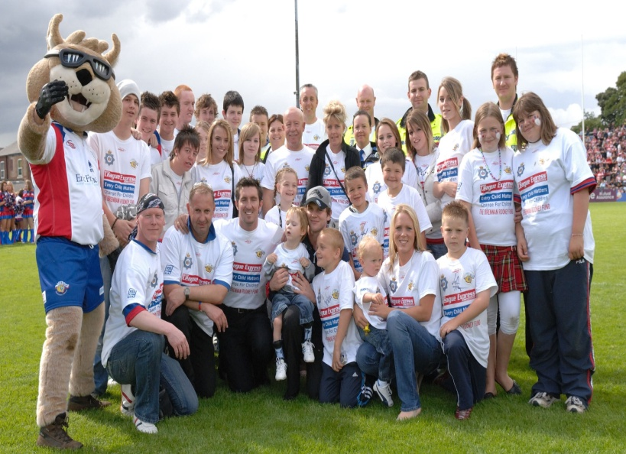 |  |  |  |  |  |  |  |  |  |  |  |  |  |  |  |  | 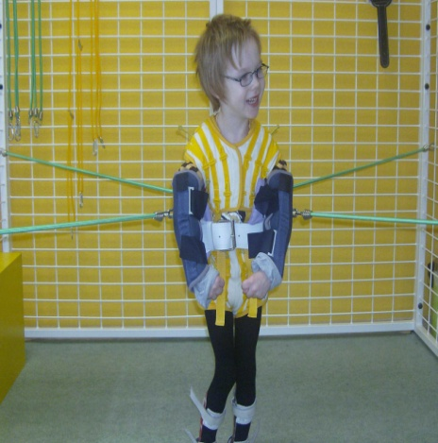
BRENNAN ROONEY FUND

The Brennan Rooney Fund was set up to raise funds to send Brennan to Germany for specialist treatment for Cerebral Palsy. PC AMOS devised, arranged and organised many events bringing the community together. The T-shirts PC AMOS devised and the charity football game West Yorkshire Police v Emmerdale All Stars raised £15,000. The NPT assisted and the RL community praised the Police involvement. The media attention evoked other young people to help Brennan and they individually conducted sponsored swims, silence and runs to raise money.

CROFTON ANNUAL ENVIRONMENTAL CLEAN UP

PC AMOS organised annual litter pick clean ups with Year 7 pupils over a 5 year period. Every year over 190 pupils would clean up their local School and surrounding community including, graveyard, shops and fields. This showed the local community that the children wanted to make a difference as the mornings were voluntary not mandatory. As an award to the winning group who collected the most litter, they all received a free ticket to a Wakefield Wildcats game. As every year group over the 5 year period took part in the clean up, it reached approximately 1000 pupils from every year group within the School from 2008 – 2012. The day also saw the Wakefield Council take away the rubbish we had collected.

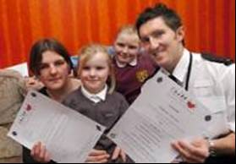

CVOC AWARD

After reading about a 6 year old girl who had been left for dead after being run over PC Amos nominated Darianne for a Child Victim of Crime Award and won. This enabled the family to go on their first ever holiday.

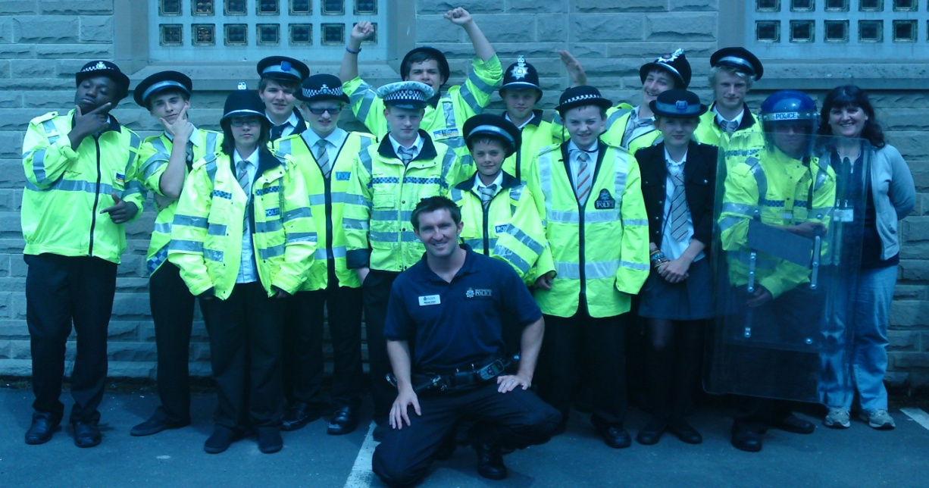

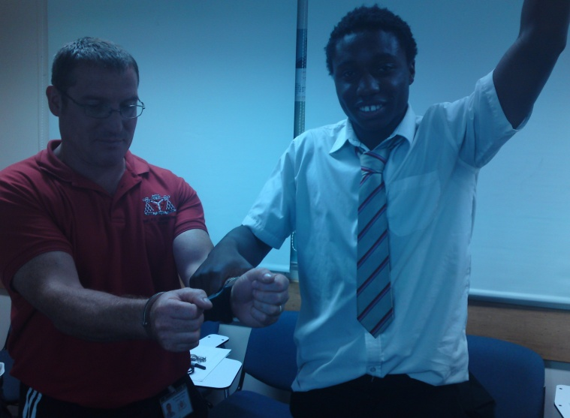
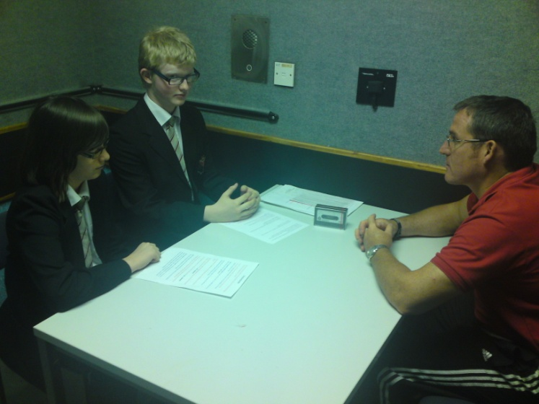
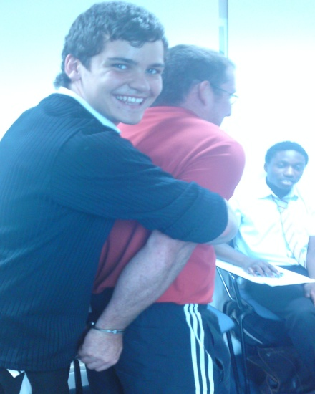 |  |  | 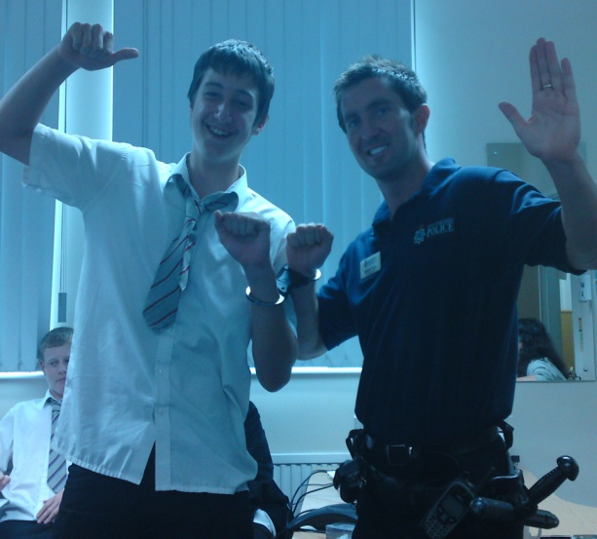 |  |  |  |  |  |  |  |  |  |  |  |  |  |  |  |  |  |  |  |  |  |  |  |  |  |  |  |  |  | 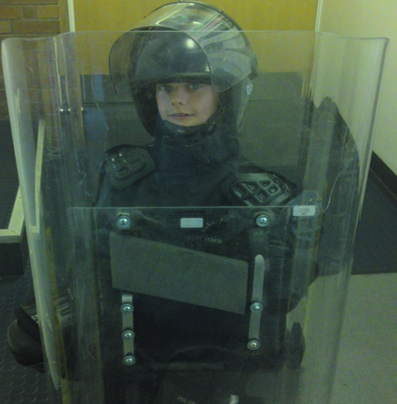
ST THOMAS A BECKETS INDUSTRY WEEK

PC AMOS was requested to assist in Industry Week at St Thomas a’ Becket Catholic College. The week encourages young people to consider the future and look at the different occupations that are out their. The week saw different pupils come up to Ossett Police Station and learn about a Career in the Police Service. The pupils conducted a Police Interview on tape, took part in a role play, learned how to use the handcuffs and baton and dressed in riot equipment. They learned the risks and difficulties of 21st century policing in an ever changing world.
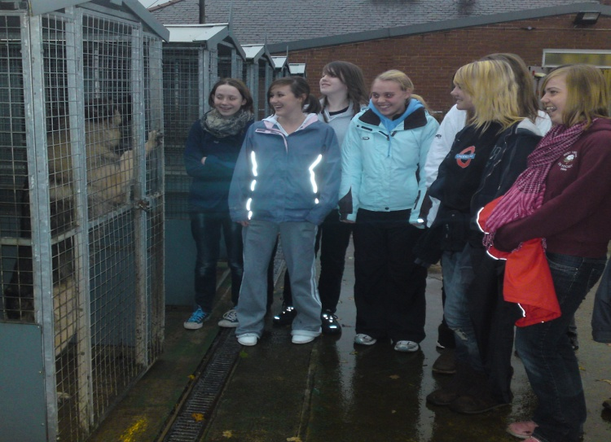
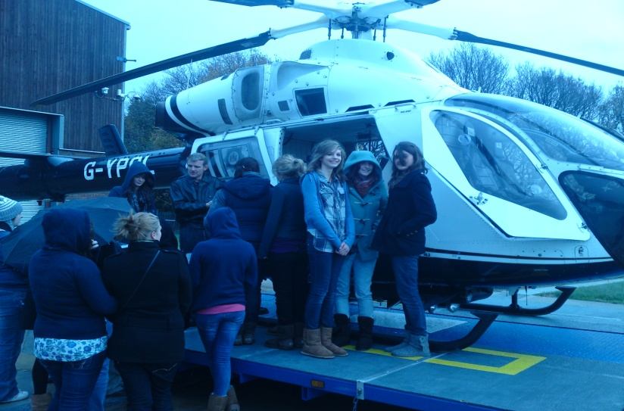

WAKEFIELD GIRLS HIGH SCHOOL CARR GATE COMPLEX CAREER VISIT

PC AMOS took WGHS pupils to Carr Gate Police Complex for the students to learn about the different roles within the West Yorkshire Police. The pupils gained inside knowledge of the helicopter, firearms, mounted and dog sections.

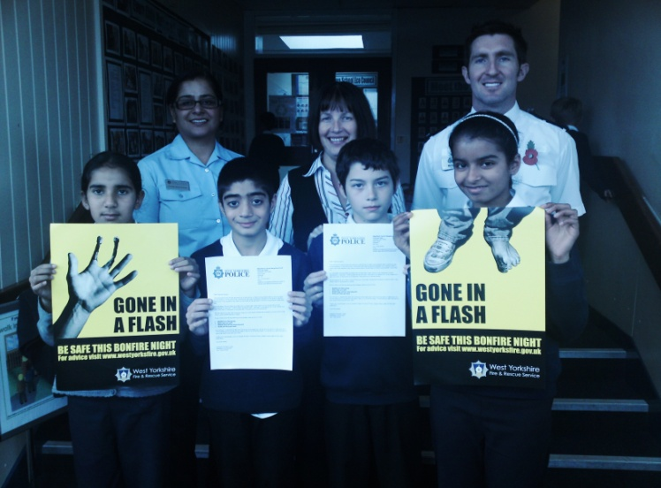
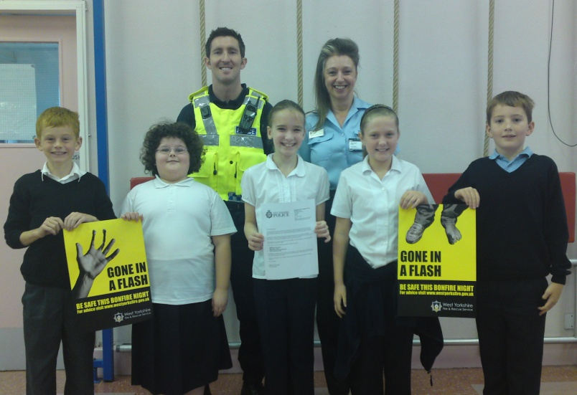
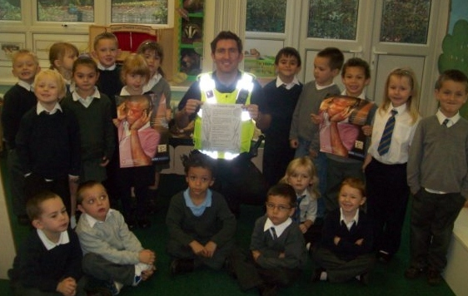

BONFIRE NIGHT AWARENESS PARTNERSHIP PRESENTATIONS

PC AMOS worked in partnership to deliver annual fire and anti social behaviour safety around bonfire night. Primary and Secondary Schools were targeted from statistics showing areas which have previously been vulnerable to injury and crime. The presentations resulted in reductions in crimes and injuries over a 4 year period.

CASTLEFORD TIGERS |  |  |  |  |  |  |  |  |  |  |  |  |  |  | FEATHERSTONE ROVERS
WAKEFIELD WILDCATS

RIVAL MASCOTS IN UNITY
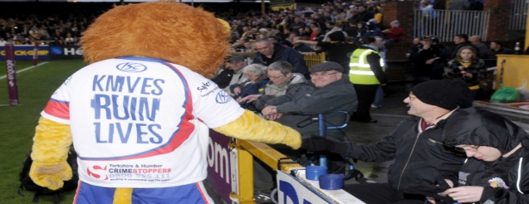 |  |  |  |  |  |  |  |  |  |  |  |  |  |  |  |  |  |  |  | 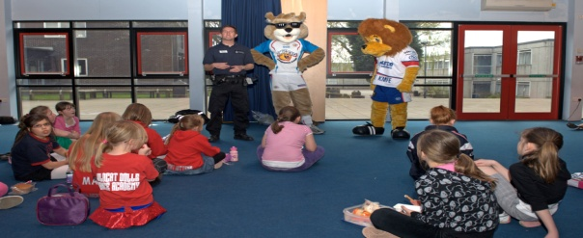
ALFIE INCLUSION PROJECT

PC AMOS conducted a project with rival rugby league clubs community departments across the district giving presentations on inclusion as part of the prevent extremism agenda. Utilising ALFIE the Main Man Police RL Mascot the presentation focused on including everyone in activities and showing respect to other people regardless of their team choice, race or religion. We visited a home game of all the districts sides with all mascots to show unity.

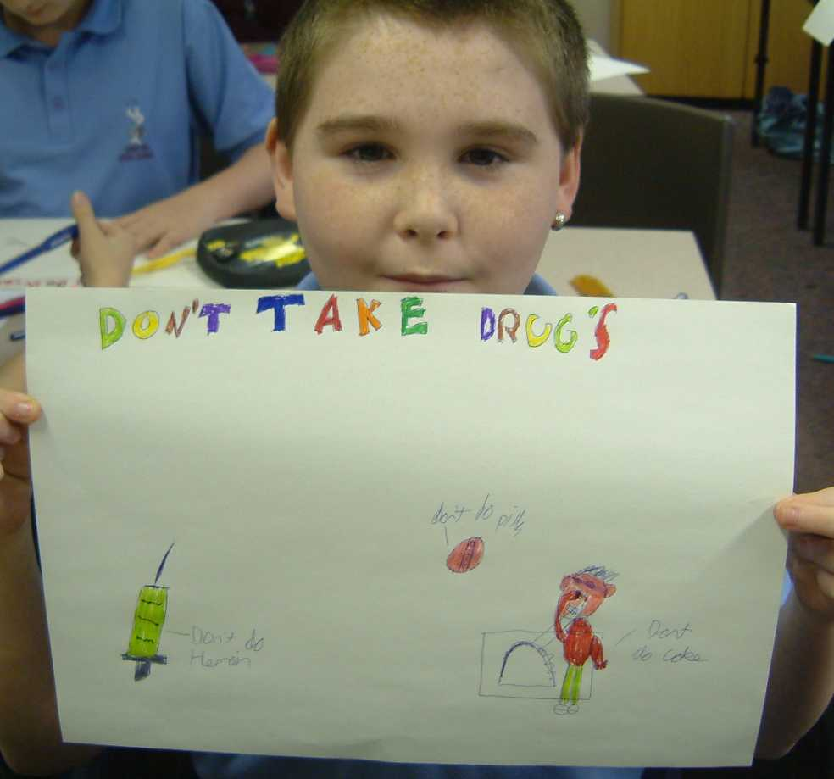
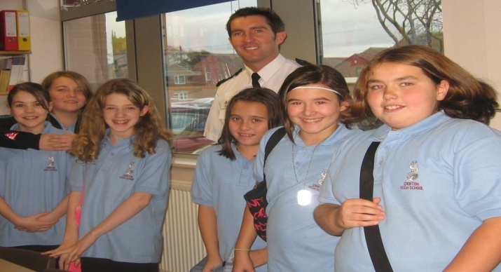

CROFTON HIGH SCHOOL SAFER PLACES DAY

PC AMOS has taken part in everyone of Crofton Safer Places Day for the past 5 years in which he delivers 7 drugs presentations giving advice to pupils around staying safe and staying away from custody. This partnership approach to safety and welfare targets Year 7 pupils who have just come up to secondary School.
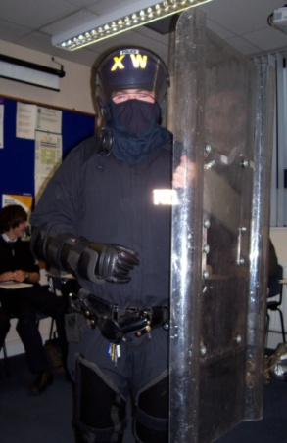  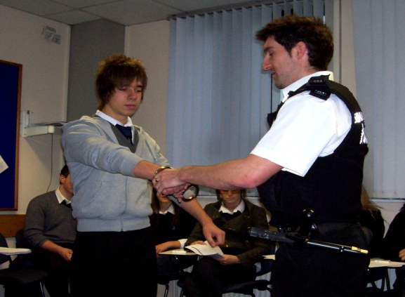 |  |  |  |  |  |  |  |  |  |  |  |  |  |  |  |  | 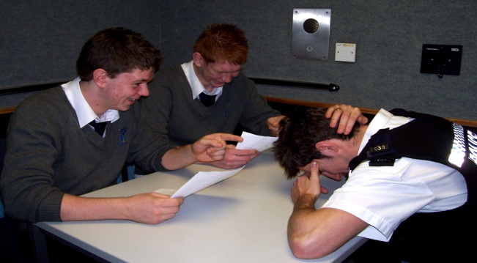  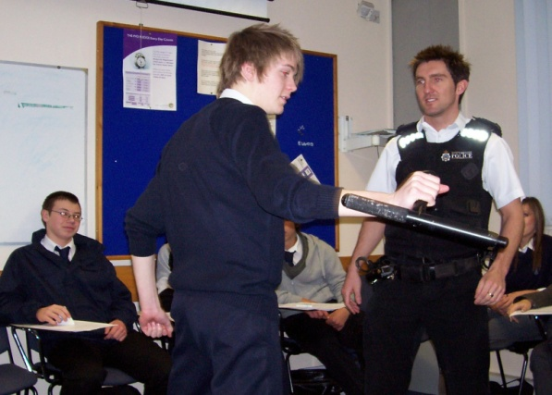
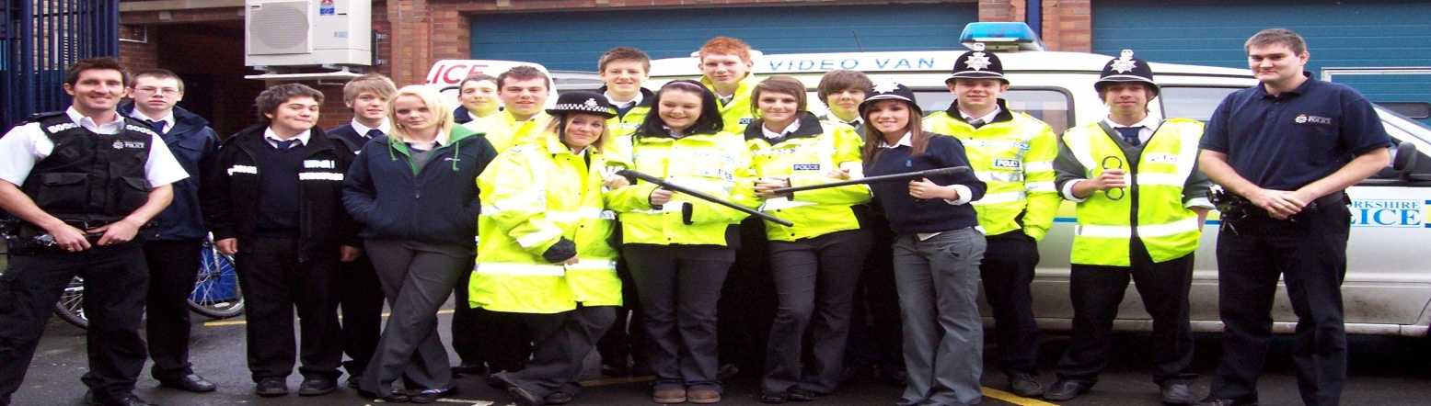

KETTLETHORPE HIGH SCHOOL STATION VISIT

PC AMOS has delivered Station visits for Kettlethorpe High pupils for over 4 years. Focused and talented achievers visit the station to learn a wide variety of information about Policing. The pupils have a mixed day of theory and practical activities that evoke their imagination. PC AMOS becomes a suspect as he gets interrogated by pupils after he is arrested for stealing from ASDA. Can the pupils get a confession?

WEST YORKSHIRE POLICE I10 COMPETITION
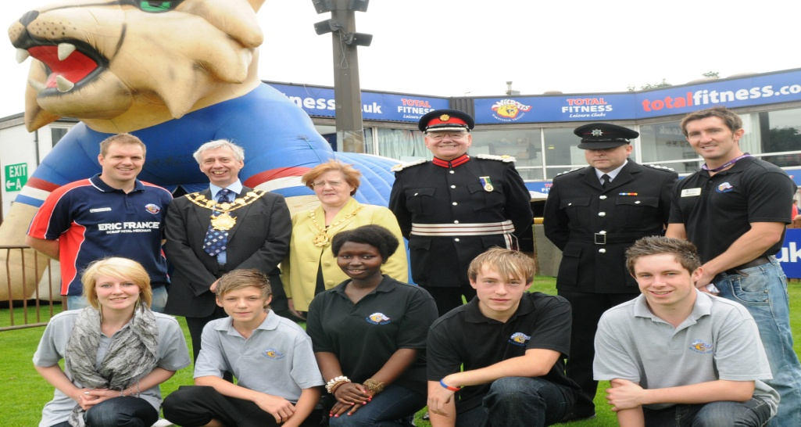

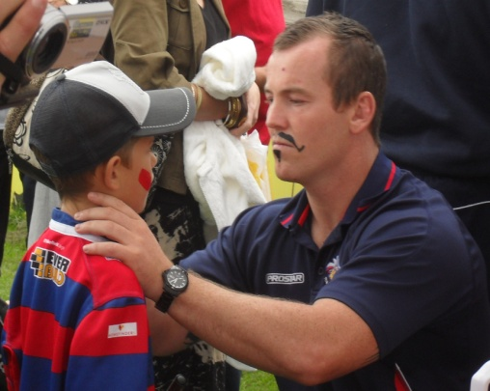 |  |  |  | 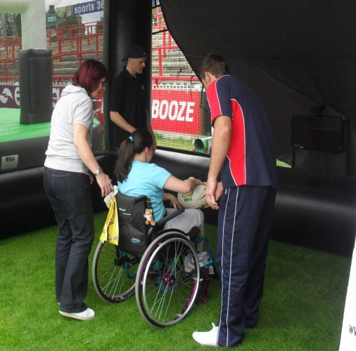
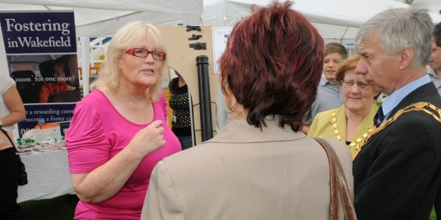
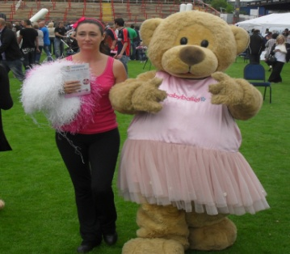
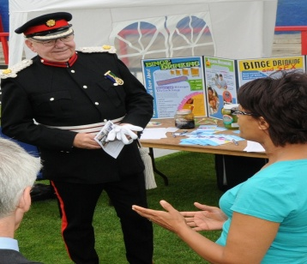
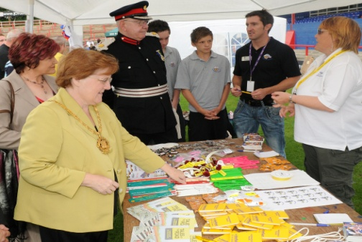  BABY BALLETT |  | FOSTERING IN WAKEFIELD |  |  |  |  |  |  |  |  |  |  |  |  |  |  |  |  |  |  |  |  |  |  |  |  |  |  |  |  |  | REBOUND DRUGS AWARENESS  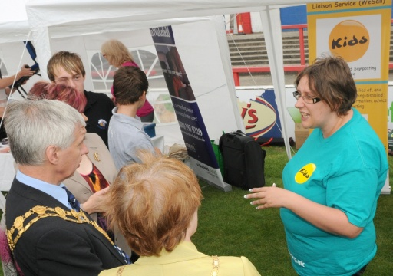
ROAD SAFETY TEAM |  |  |  |  |  |  | STAVROS FLATLEY |  |  |  |  |  |  |  |  |  |  |  |  |  |  |  |  |  |  |  |  |  |  | WESAIL – CARE FOR DISABLED
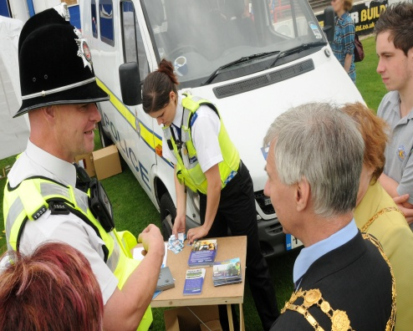  WEST YORKSHIRE POLICE |  |  |  |  |  | 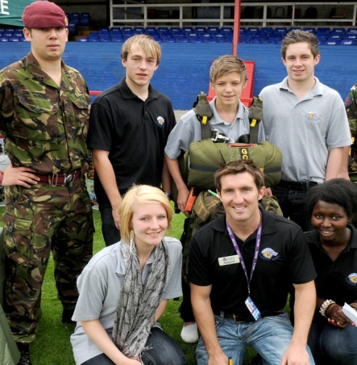  BRITISH ARMY |  |  |  |  |  |  |  |  |  |  |  |  |  |  |  |  |  |  |  |  |  |  |  | 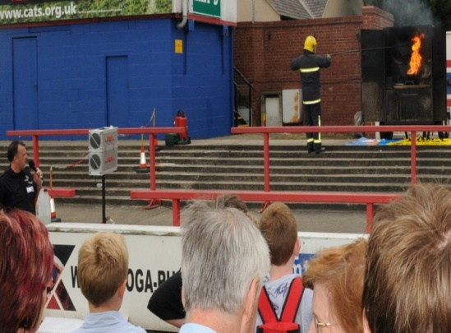  WEST YORKSHIRE FIRE SERVICE  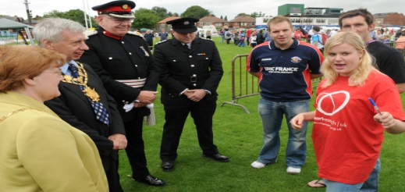
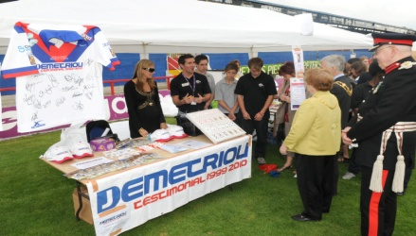  JASON DEMETRIOU FUND |  |  |  |  |  |  |  |  | MACMILLAN CANCER SUPPORT |  |  |  |  |  |  |  |  |  |  |  |  |  |  |  |  |  |  |  | HEART RESEARCH UK
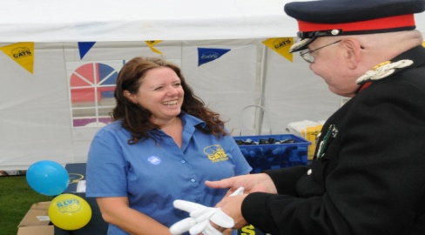  CATS PROTECTION |  |  |  |  |  |  |  |  |  |  |  |  |  |  |  |  |  |  |  |  |  |  |  |  |  |  |  |  | 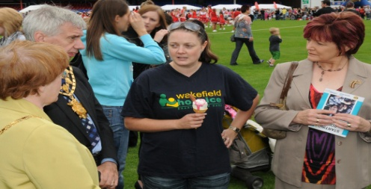  WAKEFIELD HOSPICE
WEST YORKSHIRE POLICE I10 COMPETITION

PC AMOS worked alongside I10 pupils to organise a community fun day with emphasis on looked after and disabled children. PC AMOS contacted over 12 different agencies/services as shown above to give information to the public about their organisation whilst looking after an activity to engage them. Activities included cocunut shy, basketball, football, darts, bowls with prizes to be won. All children with disabilities and looked after children within the district got free entry and a free token for a go on everyone of the 15 activities. The day was a fantastic success with over 3000 members of the community turning up to enjoy, learn and have access to key services within the district.

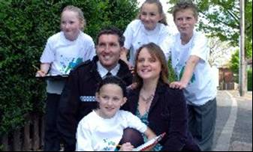 |  |  |  |  |  |  |  |  |  |  |  |  |  |  |  |  | 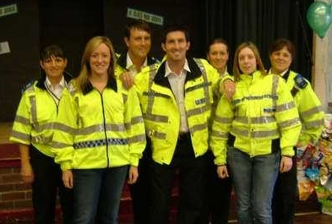
HEATH VIEW PRIMARY SCHOOL  ENVIRONMENTAL VISUAL AUDIT (EVA)  PC AMOS and Vicky Binns from Coronation Street worked alongside Year 5 pupils from Heath View to make informed decisions about their environment around their School |  |  |  |  |  |  |  |  |  |  |  |  |  |  |  |  | HEATH VIEW PRIMARY SCHOOL  XMAS FAYRE  PC AMOS and members of the NPT and teachers took part in Heath View Xmas Fayre for parents and pupils to show community togetherness.
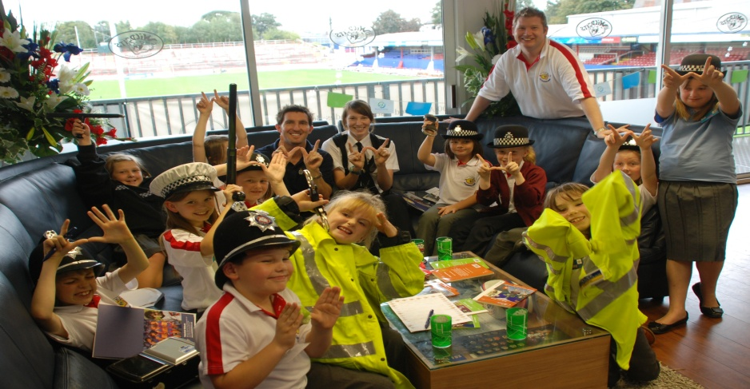
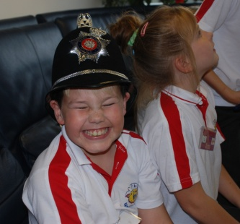 | 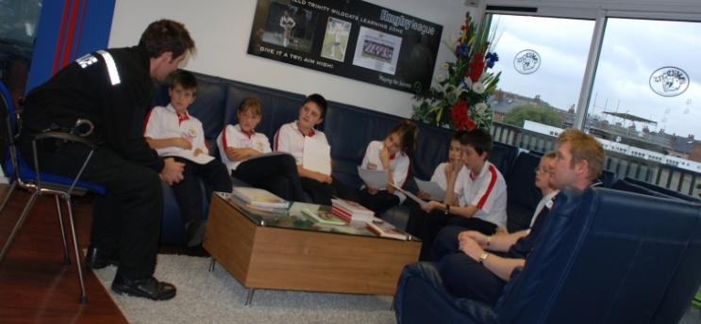 |  |  |  |  |  |  |  |  |  |  |  |  |  |  |  |  |  |  |  |  |  |  |  |  |  |  |  |  |  |  |  |  |  |  | 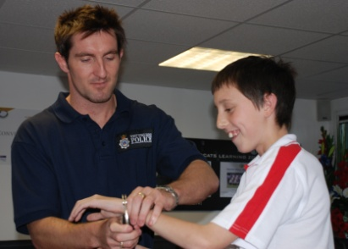
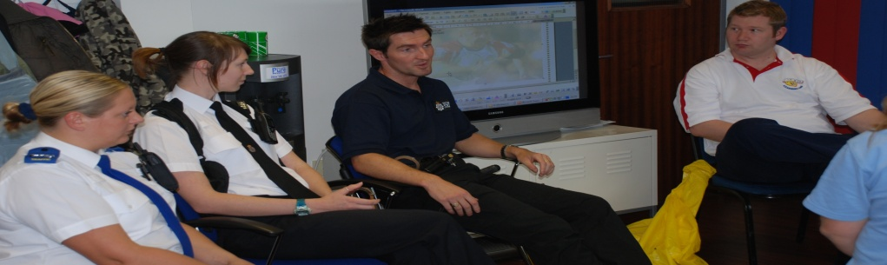

LEARNING ZONE

PC AMOS has visited the Wakefield Wildcats Learning Zone on many occasions to deliver key messages to children who require extra curriculum education in a different environment. The learning zone is part of the playing for success model adopted by the majority of professional sports clubs throughout the United Kingdom.
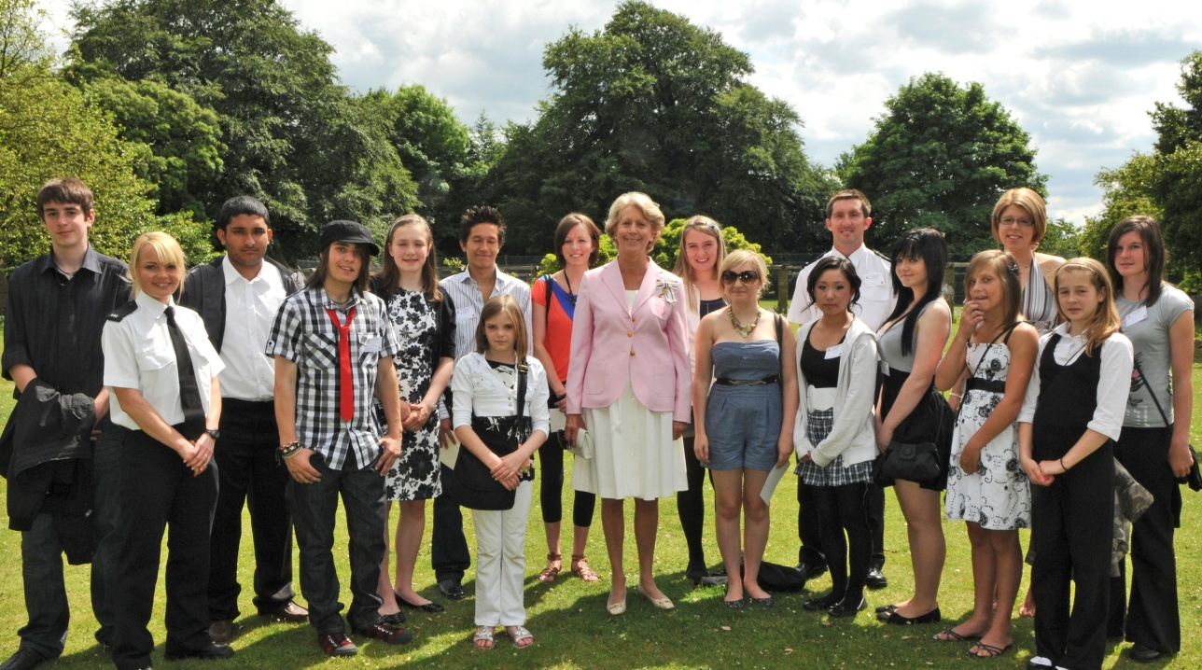

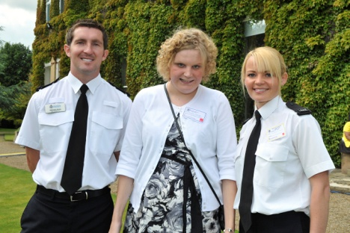 |  |  |  |  |  |  |  |  | INGRID ROSCOE  CHIEF LORD LIEUTENANT OF  WEST YORKSHIRE |  |  |  |  |  |  |  |  |  |  |  |  |  |  |  |  |  |  | 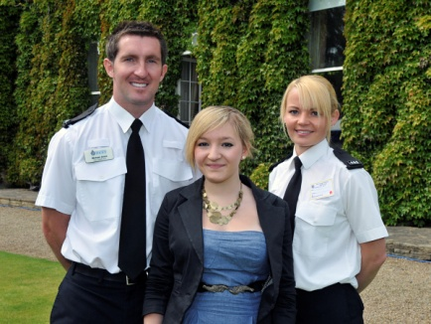
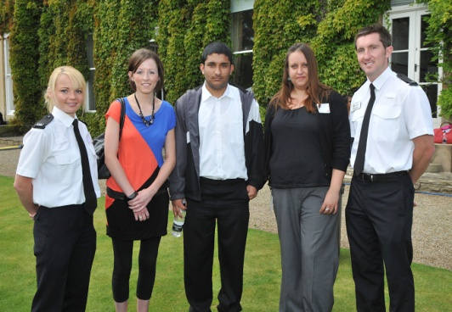 |  |  |  |  |  |  |  |  | 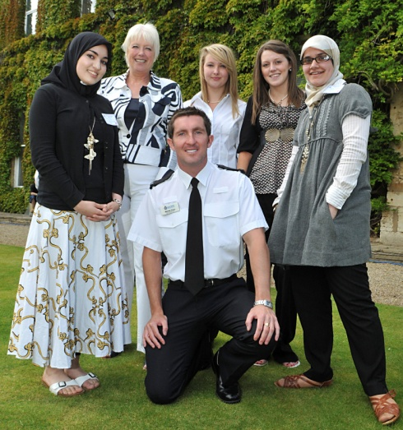 |  |  |  |  |  |  |  |  |  |  |  |  |  |  |  |  |  |  | 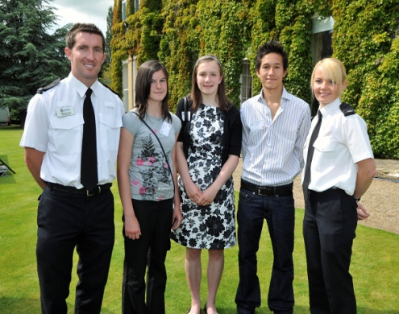
PRESTIGIOUS CHIEF LORD LIEUTENANTS GARDEN PARTY FOR YOUNG ACHIEVERS

PC Amos was requested by Ingrid Roscoe, Chief Lord Lieutenant of West Yorkshire to select young achievers from the Wakefield District to attend her garden party. The garden party rewarded young people from a variety of different backgrounds for different reasons. From excelling in academia, sport or overcoming difficult circumstances the young people did the district proud. Ingrid Roscoe is a representative of the Queen and therefore the young people had a day to remember for their individual efforts for themselves and the community they live in.
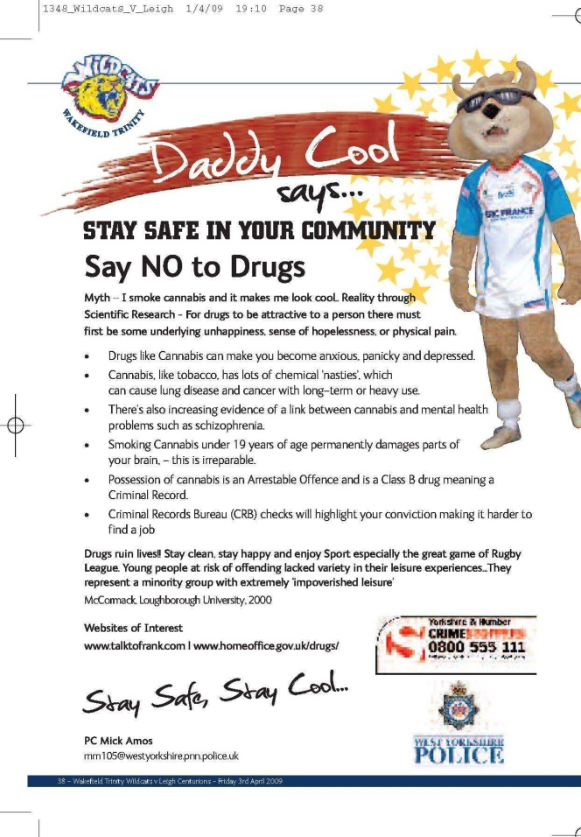  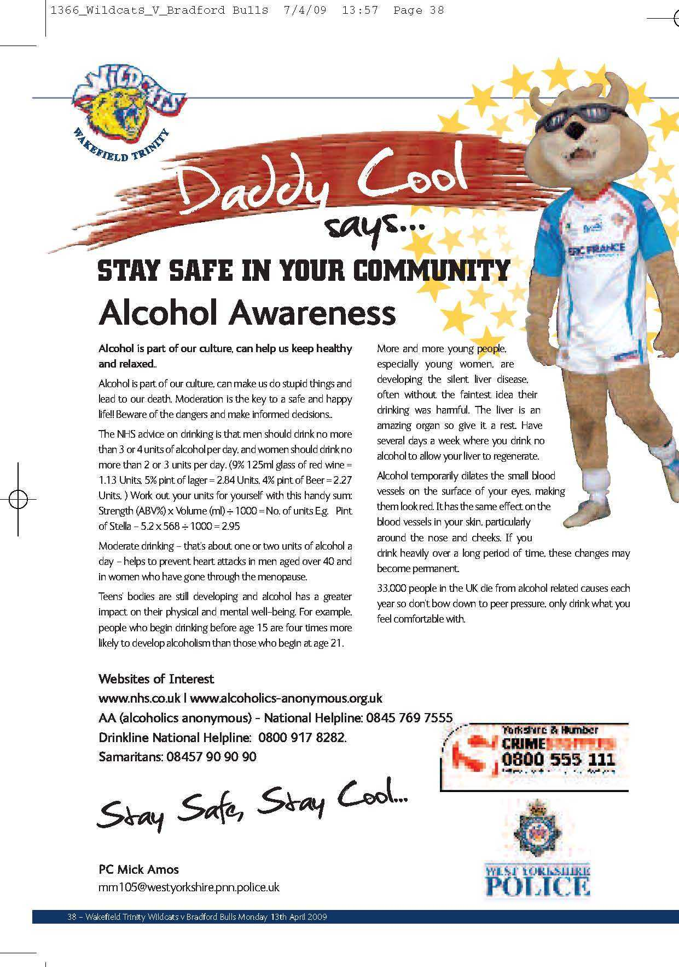 |  |  |  |  |  |  |  |  |  |  |  |  |  |  |  |  |  |  |  |  |  |  | 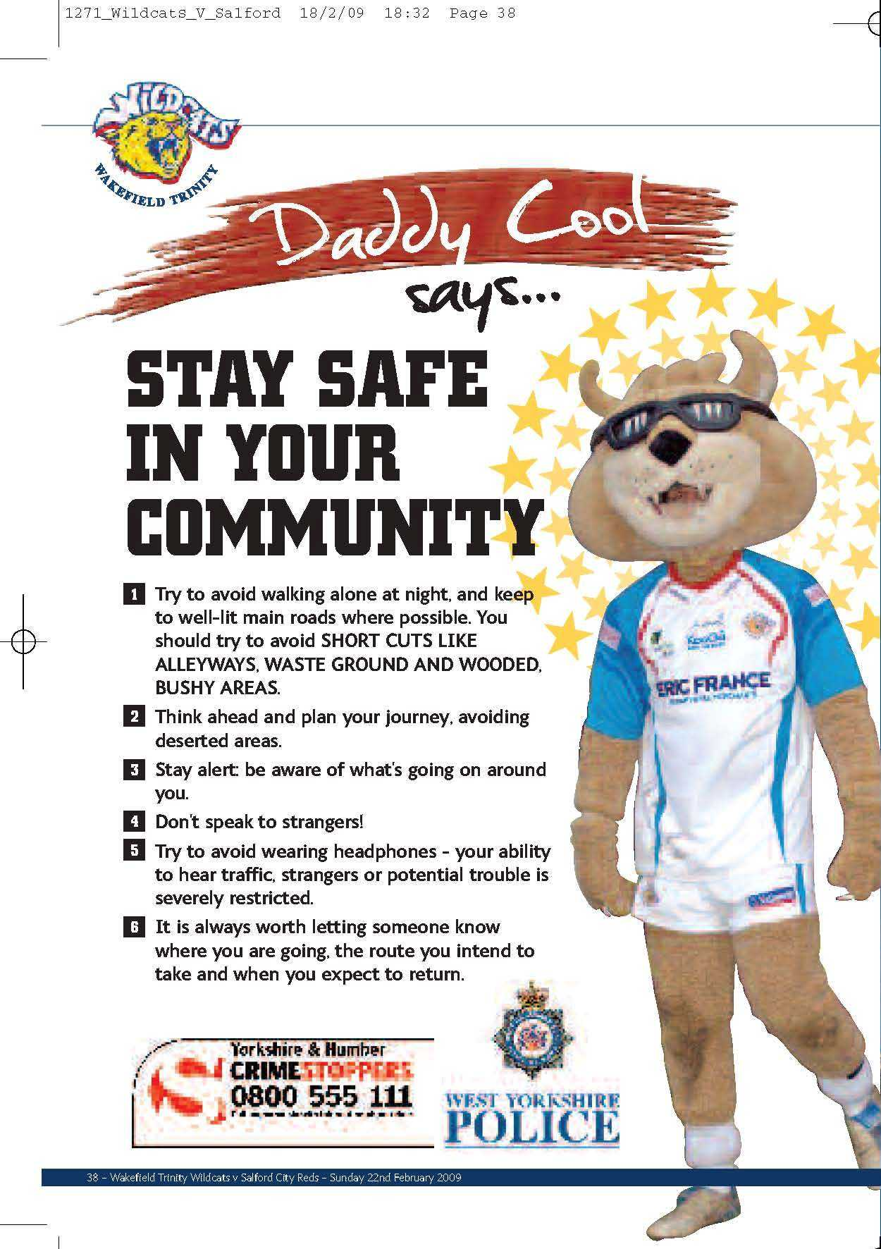
COMMUNITY SAFETY MESSAGES

PC AMOS negotiated free safety messages and advertising for CRIMESTOPPERS and WEST YORKSHIRE POLICE. PC AMOS wrote a different safety message in each of the Wakefield Wildcats programmes for the 13 games they played at home. Ranging from road safety, cyber safety and say no to drugs, the information reached thousands of fans. The average home attendance was 6, 500 fans.

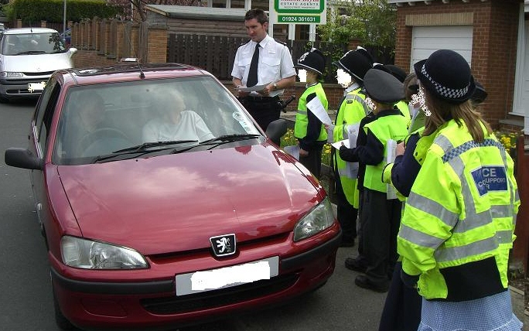

ST JAMES PRIMARY PARKING SAFETY OPERATION

PC AMOS responded to Schools who highlighted a problem with pupil safety around School opening and closing time. Letters were devised which told parents to think of children’s safety when driving and parking in and around the School. The letter also contained the Highway Code and Green Cross Code for the pupils and parents to practice at home.
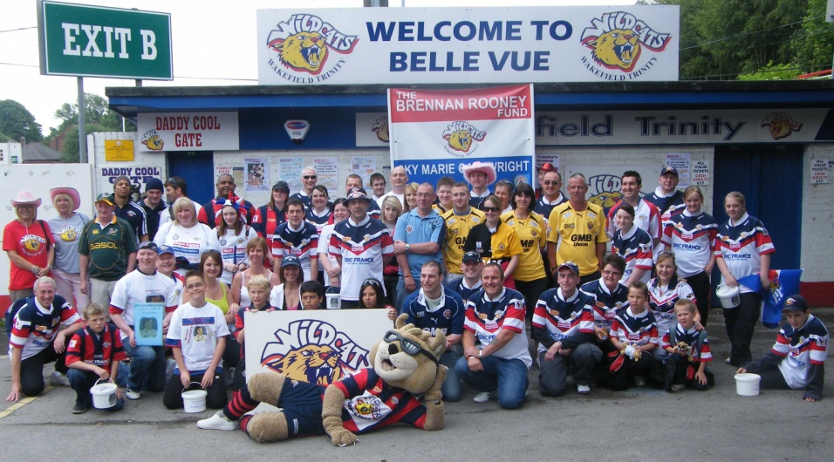

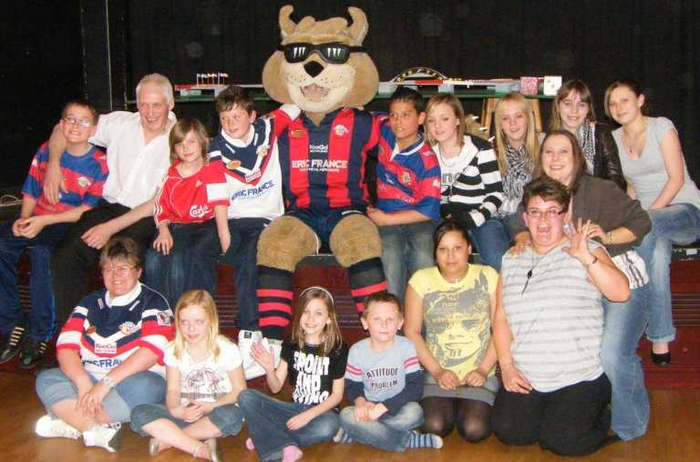
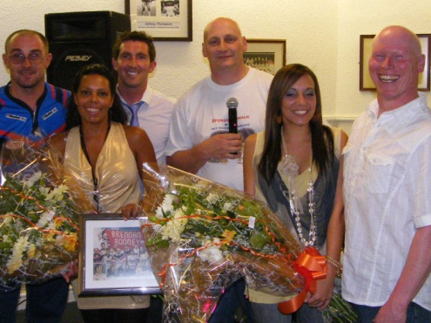
SKY CARTWRIGHT COMMUNITY FUNDRAISING EVENTS

PC AMOS organised rival rugby fans young and old to do sponsored walks and events for a local Castleford girl who needed to raise money for specialist treatment to stop her going blind. The events brought the local teams together off the field to raise money and show other fans that despite whichever team you support off the field you can come together for a good cause.

WEST YORKSHIRE POLICE I11 COMPETITION

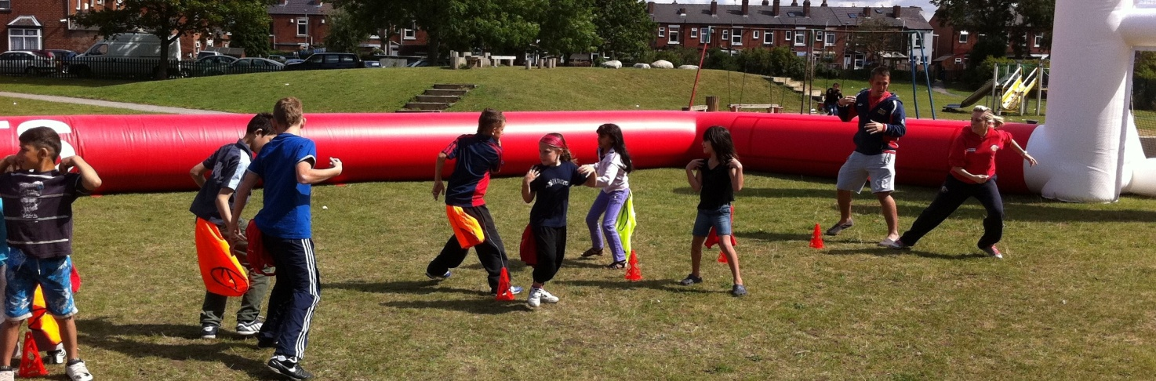

WEST YORKSHIRE POLICE I11 COMPETITION

PC AMOS organised an Agbrigg community activities week. Throughout the week 75 young people aged between 4-16 years of age from 8 different nationality and religious backgrounds attended the camp. They played and engaged in a variety of different activities free of charge. The week was topped off with a FREE ticket to watch Wakefield Wildcats v Castleford Tigers through PC Amos Ambassador Role at the club. 90% of the children had never been to a live sporting occasion and they enjoyed every moment from watching the game meeting the club mascot Daddy Cool.

Acknowledgements

“The quality of work delivered by PC AMOS to our School over his many years of service has been impeccable. He has excelled in all aspects of his work here ad we cannot question his professionalism, commitment or the support he has provided for our pupils, parents, staff and the community as a whole”
Mr Jez Horsley – Headmaster Crofton Academy, 2012

“I have in the 2 years I have been at Beckets, have been able to utilise the support provided by PC AMOS”
Mr John Rooney – Headmaster St Thomas a’ Becket Catholic College, 2012

“Over the time we worked with PC Amos the School staff and pupils clearly valued his presence, advice and inputs. This was endorsed by the wider community including parents and relatives who often attended information evenings and workshops that were delivered and led by PC AMOS and supported by his colleagues and other agencies. As a colleague we valued his working professional knowledge, reliability and positive outlook”
Mr Tudor Griffiths – Headmaster Kettlethorpe High School, 2012

“On behalf of the college can I thank you for your support and remind you of the invaluable work you have done for us over the last 5 years. You have been a constant source of support, providing care and guidance to staff, parents and pupils. All of this has been done in a very professional way and you have worked very hard to accommodate all requests that have been made upon you, many of which have been done out of your normal working hours”
Mr John Firth – Assistant Headmaster St Thomas a’ Becket Catholic College, 2012

“As a teacher at Kettlethorpe High School for over 30 years I have seen the development of Police Involvement in School and PC AMOS has proved himself as the best and most effective Police presence we have had in that time.
He is always ready and able to advise me on the best way forward with a youngster, often out of hours
and when not on duty. His presence, knowledge and relationship with difficult pupils at these times
have prevented situations arising or escalating”
Mr Nick Hooley – Head of Year Kettlethorpe High School, 2012

“PC Mick Amos has been a valued member of the support staff linked to Kettlethorpe High School. Over the last few years PC AMOS has provided enthusiastic, positive and proactive support to our pupils In a variety of areas”
Mr Rob Douglas – Head of Year Kettlethorpe High School, 2012

“Large parts of the ward has a very diverse ethnic community, which needs a sensitive and knowledgeable approach, Mick has shown he has those qualities. Mick has always approached his work with a professional manner
and has a great ability to bring partners together to work on projects”.
“Mick listens to the community to meet their needs and this is reflected in his ability to work with a wide range of people, both lay ad professional from different backgrounds and diverse communities”
Mr Majid Sadiq – WMDC Community Development Officer, 2012

“I write in support of PC MICK AMOS and the excellent work he has done, and continues to do on behalf of our School. He is always at the other end of the phone and often drops everything to come in if there is an emergency. It is easy to calculate the effect his support has upon the individual girls, parents and staff he works with. However just as important is his preventative effect upon the girls behaviour and making them think more carefully about actions that could have devastating consequences for their future lives and well being, as well as their curriculum vitas.”
Mrs Gillian Wallwork – Headmistress Wakefield Girls High School, 2011

“I have built an excellent working relationship with him over time, as have many of the staff here. He is well known and liked by the boys who respect him for his fairness, sense of humour and approachability” “Mick can always be contacted and whilst at times he can be busy or called away to other priorities, in our experience he is very diligent and can always be relied upon. When I have needed to contact him over significant issues or emergencies
sometimes outside of School hours, his response has been very swift and well judged”
Mr Jim Palin – Deputy Headmaster Queen Elizabeth Grammer School (QEGS), 2011

“Thank you so much for the talk you gave to pupils of Kirkhamgate School. It was informative and enjoyable and the children got a lot from it. I look forward to future visits”
Mrs Julia Owen-Smith Deputy Headmistress, Kirkhamgate Primary School, 2011

“The fact you dropped everything on more than one occasion to come and assist was brilliant
and gave me and my colleagues a huge sense of security” “The respect that you hold in School with both pupils and staff is to be commended and how they interact with you is a joy and so important to break down barriers that often outside influences cause pupils to put up when dealing with the police”
Mrs Jane Richardson – Behaviour/Attendance Officer, Kettlethorpe High School, 2011

“The wide ranging ‘Early Intervention’ work he carries out is extremely effective in preventing and allowing our students to have much needed clarification of boundaries within the law. PC AMOS has established broad links with our parents and work has extended to holiday periods when our students are most at risk of offending or are vulnerable. This service is crucial to our provision and his presence is much appreciated and valued”
Mrs Charlotte Lawson-Wright – Senior KS3 Autism Resource, 2011

“The work of PC AMOS ‘S intervention was what stopped the situation, and I feel that I had to tell my story so you can see what the service did for my son and my family. ****, has changed so much and is a totally different child, he has great respect for PC AMOS and knowing he has helped him in the past has given him confidence”
MRS Sarah ***** - Parent, 2011

“I refer to the Agbrigg Community Week delivered by PC AMOS and Majid Sadiq”
“The School Liaison Officers and Sport 4 U are an essential part of the success of these projects as a familiar face can make a big difference to the confidence of pupils and their parents in being involved. At a later community event I could see the difference in the attitude to the police presence, as a result of the good work that had been done”
Councillor Monica Graham – Wakefield South Ward 19, 2011

“Your presence in around School has certainly been proactive in ensuring youngsters behave appropriately in a safe and secure environment. It is also important to say that your relaxed demeanour and charisma has certainly ensured that the Police are seen in a positive light by the majority of pupils in School” “Finally you were always willing to help out with after School events and attended many charity and social gatherings for pupils in your own time”.
Mr Gareth Mellor – Assistant Headteacher, Kettlethorpe High School, 2011

“We understand that as the Police School Liaison Officer for the School, you did not have to put in all the effort that you did when supporting us. We are also very grateful you took time out of what must
be a busy schedule to accompany us to London for the final”
Life Team Pupils – St Thomas a Becket Catholic College, 2011

“We would like to thank you for your participation in Ossett Academy Sixth Form Interview Day. The staff and students are very grateful and appreciative of your input and that you have given up your time to assist”
Mrs S Parfitt – Administration Manager Ossett Academy, 2011

“The children got so much from your visit, I thought you dealt with their questions really well”
Mrs Emma Bissit – Nursery/Foundation Teacher, St Hildas Primary School, 2011

“Once again thank you for providing the pupils with an invaluable insight into your work. The girls really enjoyed your talk and I am sure it gave them food for thought when considering their future options”
Mrs Sarah Duerden-Brown, Head of Sixth Form Careers WGHS, 2011

“Letter of support from PC Mick Amos is great. At such short notice we only expected a couple of lines stating the Police support the Secret Garden Project. Please thank PC Amos on our behalf, the letter will help to support the funding for the elements of the garden that cannot be completed by volunteers and requires specialist contractors”
Mr Ian Deighton – Friends of CHAT (Clarence, Holmfield and Thornes Park), 2011

“We learnt a great deal about law and order and enjoyed playing ‘Who wants to be a Millionaire’ ”
Year 6 Pupils – WGHS Junior School, 2010

“Further to your last few visits to Sahara Youth Centre, I would like to inform you that the young people have thoroughly enjoyed the conversation and trust you have gained with these young people.
It is very difficult to engage with these young people but your visits has made a huge
difference to their perception of the Police and how they work”
Mr Jahangir Khan – Sahara Co-ordinator and Community Behaviour Officer, 2010

“Your presentation greatly enhanced the pupils perspective on training and employment within the Police Force”
Mrs Janet Sharkey – Careers Coordinator Kettlethorpe High School, 2010

“Michael has held regular meetings to encourage Jordan to achieve his academic potential and
to aid progression into further training and education opportunities”
Mrs Lesley Franks – Project Co-ordinator CEBS Aim Higher, 2010

“I am told the organisation of the event owed much to your initiative and efforts” “One of the constant joys of my involvement in policing is the connection that is still alive and well between the force and people in the community. That is why neighbourhood policing, as our predominant style, is so important to me. The success of the relationship relies however, on the unsung efforts of people like you who day in and day out, connect with young people in the Schools of Wakefield and who put a great deal of effort into providing a platform and building good community relationships. I know that these efforts include not only duty time but your own time as well.”
Sir Norman Bettison – Chief Constable, West Yorkshire Police, 2010

“Our Students found both presentations really interesting and I have a lot of very positive feedback from the learners. Our staff who were in attendance felt that both presentations were pitched appropriately
for our students and the approach of both officers was excellent”
Mrs Catherine Taylor – Pennine Camphill Community, 2010

“I am just writing to say thank you for all your help and support at Wakefield family fun day. It was a great day all round and it was wonderful to be a part of the activities that ran throughout the day. It was also very kind of you to let all the stall holders keep the original float. Thank you for helping us continue this pioneering work”
Mrs Phillippa Harrison – Fundraising Assistant, HR UK, 2010

“PC AMOS this is a very good PDR. You are obviously performing well in a role you enjoy.
Keep up the good work and thank you”
Chief Inspector Derek Hughes - NPT Chief Inspector, West Yorkshire Police, 2010

“Recently various Schools have been asked for feedback on their respective Y.S.O. I have seen on this feedback that all School heads have positively commented on PC Amos courtesy and politeness. PC AMOS clearly demonstrates that he is a highly motivated officer who takes pride in, and has a high level of personal responsibility with his work”
Inspector Lee Carlson - NPT Rural, West Yorkshire Police, 2010

He regularly performs above and beyond the call of duty to help each individual in the college. PC AMOS is a
very approachable police officer and I can say without doubt that many students would have no trouble in
approaching him to discuss any issue” “PC AMOS is an excellent role model to the whole community”
“It is a privilege to have PC Michael Amos as our School Liaison Officer. He is a credit to St Thomas
a’ Becket Catholic College, to West Yorkshire Police and most of all the whole community”
Alistair Field – Deputy Head Boy Pupil, St Thomas a’ Becket Catholic College, 2009

“On behalf of the girls and staff at Wakefield Girls High School, thank you for your assistance with the movement of everyone from School to Wakefield Cathedral for our Advent Service. It was both helpful and beneficial”
Mr David Eggleston – Deputy Head, WGHS, 2009

“Dear Mick I am so touched that I cannot find the proper words to say thank you.
You did so much for the garden party”
Dr Ingrid Roscoe – Chief Lord Lieutenant of West Yorkshire (Representative of the Queen), 2009

“Even though you did 6 presentations while I was present, you put the same enthusiasm into each delivery” “I have informed the Tenants and Residents Association in Kettlethorpe, that there is a high level of education regarding crime happening in all School across the district, and am convinced this will go a long way to achieving our aims”
Councillor Monica Graham – Wakefield South Ward 19, 2009

“The event has gone very well and I want to thank PC AMOS for his help which was brilliant”
Mrs Sam Underwood – Year 6 Teacher Towngate Primary School, 2009

“The Express was really pleased to be involved. It was very realistic thanks to the enthusiasm of PC AMOS”
Mr Don Mort – Wakefield Express Reporter, 2009

“I don’t think I have ever met someone as dedicated to changing peoples lives for the better as you”
Mrs Joanne Allridge – ASDA Events Coordinator, 2009

“I would like to recommend PC Mick Amos for an award of £500. As highlighted in the JNCC his contribution and efforts over the past 12 months have been outstanding” “He excels well above my expectations, he is flexible, passionate, and genuinely wishes to make a difference within his community”
Inspector Helen Brear - NPT Rural, West Yorkshire Police, 2009

“This has been an ongoig project at VIPER and your established relationship within the local Schools
has significantly contributed to the enhancement of youths on the VIPER volunteer database”
“I hope your excellent working relationship continues with the VIPER database team”
Mr Wayne Collins – Manager National VIPER Bureau, 2008

“Thanks once again for your great presentation. Both staff and pupils found it most informative and enjoyed your workshop. Along with Martin Speak your workshop was one of the most popular with the pupils”
Mrs Kath Butterworth – PHSE Safer Places Day Coordinator Crofton Academy, 2008

“I would like to take this opportunity to thank you for your support during our recent mock interviews. Many of the students spoke of the friendly, supportive advice given by their interviewers and I would like to express my gratitude to you enabling such a positive learning experience to take place”
Mrs Beki Clark – Progression Routes and Careers Co-ordinator Crofton Academy, 2008

“He has always been incredibly helpful but just recently there has been one or more occasions where his assistance and advice was invaluable. PC AMOS is always very approachable and yet completely professional
and we feel he has been a real asset to the school”
Mrs Pat Langham – Headmistress Wakefield Girls High School, 2008

“Mick has a very calming but authoritative manner which creates respect in both adults and children. He is exactly what one hopes a Policeman will be – efficient, cheerful, reliable, and utterly trustworthy”
Mrs Lynne Brooks – Deputy Headmistress Wakefield Girls High School, 2008

“The children have thoroughly enjoyed learning about your role within our community. It was a positive experience for all the pupils and left them with a clear understanding of how the police are there to
advise, protect and maintain the law for the benefit of all”
Mrs Lorraine Martin-Speight – Catholic Care Learning Mentor / Social Worker 2008

“Wakefield College is very proud of their students, both past and present and is always happy to hear about what former students are doing now, particularly when they have gone on to be successful in their chosen field.
I am very grateful, therefore you have agreed to speak at this event this year,
I am sure you will be an inspiration to our audience”
Mr Amir IIyas – Senior Marketing Officer Wakefield College, 2008

“Thank you for showing us the Police Station on Wednesday. I most enjoyed being the riot bobby”
“Now I cant wait to join the Police Force”
Brendan Oldroyd – Pupil, Kettlethorpe High School, 2008

“One of the key points in the initiative is staying safe and PC Mick Amos has kindly offered to help young people of Horbury by talking to them about staying safe in the community” Youth and Schools Liaison Officer PC Mick Amos has carried out a great deal of work within the community to help the young people in our area”
Mr Mark Winder – Community Trust Manager, Wakefield Wildcats, 2008

“We’re delighted that PC AMOS and DS Stead brought the New Zealand rugby team to visit the children on the ward and in the regional burns unit. The visit certainly put a smile on their faces. Visits such as these help to speed up our young patients recovery and we’re really grateful that they took the time to drop in”
Mrs Rita Cammidge – Children’s Play Specialist, Mid Yorkshire Hospital NHS Trust, 2007

“As Greg’s parents we were delighted that you had taken time to send Greg a reference regarding his participation in the fundraising activities for Brennan Rooney. On a similar note we would like to thank you for the work experience day that you organised for St Thomas a’ Becket’s School. Greg participated in this too and thoroughly enjoyed his day. It reinforced his intention to become a Police Officer”
Mr and Mrs Harrison – Parents, 2007

“As a Police Officer and active fundraiser, we are proud of the fact that you have done so much in your career
and thought you would make an excellent role model for us to use for children to look up to”
“As such I would like you to become an Ambassador for the Wakefield Wildcats Community Trust”
Mr Davide Longo – General Manager, Wakefield Wildcats, 2007

“We would like to thank you for making time to visit us last Tuesday. The children and staff really enjoyed meeting you, seeing the police car and hearing all about your work”
Foundation Stage, Rooks Nest School, 2007

“Despite heavy rain and worsening conditions you persevered. Identifying colleagues who had endured these conditions for hours, you offered them hot drinks and the chance of 10 minutes relief. Realising the scale of the situation you obtained full uniform and made yourself available to the division for continued deployment. You worked approximately 12 hours and maintained a professional and positive outlook at all times.
Your enthusiasm and willingness to contribute to teamwork is evident in all your work.
Your work ethos is a credit to yourself and the spirit of the neighbourhood policing”
Sergeant Darren Norgate, NPT South West, West Yorkshire Police, 2007

“The children gained such a lot from your talk and demonstration and had lots of questions answered.
They are all looking forward to your next visit”
Mrs D P Stanyard – Headmistress, Mackie Hill J&I School, 2007

“Thank you for visiting us last month. We had a fantastic morning with you and the children really gained a lot from you chatting to them. They especially loved seeing your car and talked about you for the following few weeks”
Mrs Alison Smith – Foundation Stage, Lofthouse Gate Primary School, 2007

“The work you did with year 5 and 6 on Monday gave them plenty to think about and I am sure made a large number of them realise the dangers. I am aware of how great your workload must be and I do thank you for giving your time to us, and even being prepared to stop and answer questions afterwards”
Mrs Hilary Dalgleish – Headmistress Stanley St Peters, Church of England Primary School, 2007

“I would like to take this opportunity to thank you for coming into School to talk to my year 6 class. They were very interested in the DVD you showed them and listened attentively for a long time to your
explanations about policing in the local community”
Mrs D T Adams – Year 6 Teacher, St Johns CE (VA) J&I School, 2007

“The amount of work Mick has put in over the year in the local area has been outstanding and he has helped put Wakefield Wildcats and Brennan Rooney fund on the map with local School children”
“A testament to the guy’s commitment”
Mr Mick Atkinson – Community Resident, 2007

“We would like to say a THANK YOU for the lovely day out on Sunday. Charlotte had a lovely day and we all enjoyed it as a family. Keep up the good work that you do and once again THANK YOU”
Mr and Mrs Daniel – Parent, 2007

In a Schools Liaison capacity PC AMOS has liaised with over 35,000 people including pupils, teachers, parents, partner agencies, councillors and general members of the community.

